Ellon Academy Parent Council Meeting – 14 September 2022
ellonacademyparentcouncil@gmail.com

Attendees: Angela Stott, Pauline Buchan, Karen Gray, Wendy Jones, Fiona Callan, Ruth Leuchars, Roslynn, Karyn Grassick, Mark, Susan Madden, Frank Rymes, Louise McAlister, Jan, Gordon Burgess, Nicholas, Nick Topping
Apologies if we missed any attendees from the list.

Welcome and apologies:
Apologies from: Sarah Warne, Kim Finlayson

Minutes of last meeting:
No issues noted with minutes, but they still need to be put up onto the Facebook group. Angela will do this and if she has problems ask Karen.

Treasurer’s Update
Get Dave, Ruth and myself get together for a handover. Is there anything that the school would like us to spend the money on? Nothing noted at this time.

Rector’s Update
Demand for HE is high in the senior school which means that only 2nd year are timetabled for HE. 24 weeks of practical and the rest of the time digital skills.
Cuts to the library service have also impacted on the school. Unfortunately, now the school don’t have a library assistant and Jan Murdoch is the only staff member in the library, PSA literacy support is to be appointed into the library faculty to support this and other faculties to allow continuation of lunchtime homework clubs etc.

Key Themes/Improvement Plan
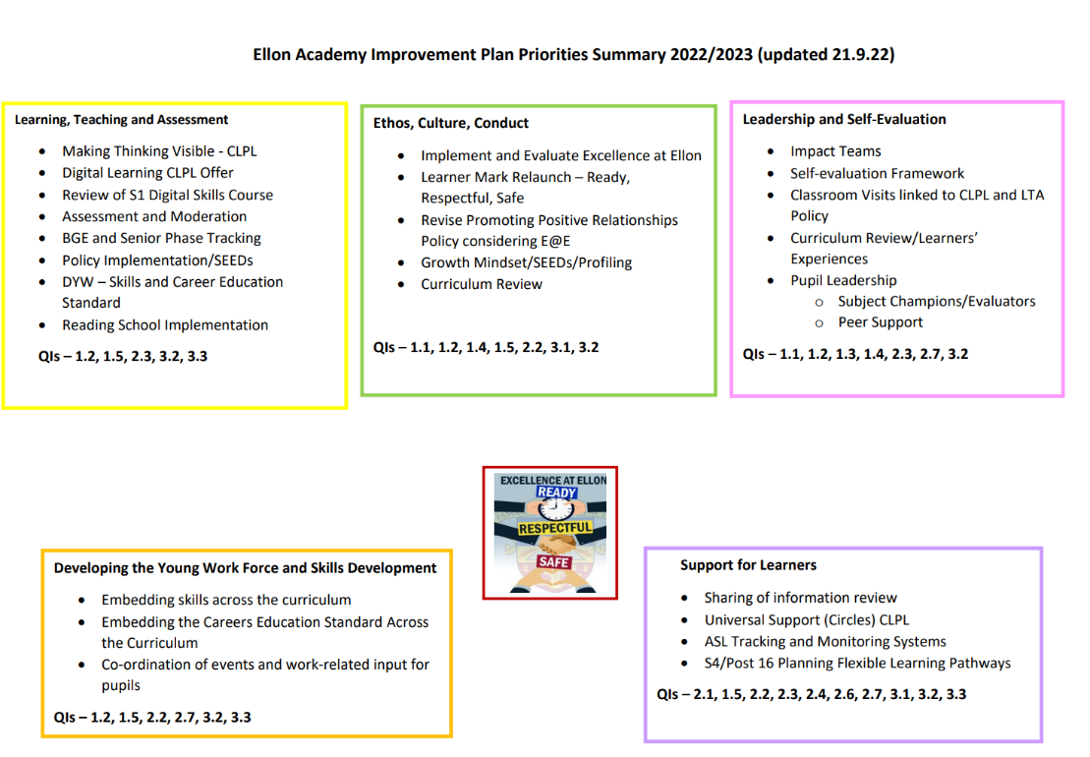
Learning, teaching & assessment
Further develop tracking of progress particularly in S1-S3
DYW – things from 2 year ago didn’t progress because of Covid, this is being revisited.
Reading School Accreditation Implementation – In partnership with the library the school is going for Silver in this standard but will be pushing for Gold. Involves the promotion of reading in the school in all areas and helps to improve attainment.

Ethos, Culture, Conduct
- Surveys of Staff and parents to come.
- Learner Mark, focus on being ready, safe and respectful within the school.
- Positive Relationships. Policy to be revised in light of the new school ethos.
- Growth Mindset/Seeds
- Curriculum review, Mr Cowie working on this. We now have a full senior phase in S4/5/6, S4 was previously separate because of the way the curriculum was structured. This improves choice for all pupils in the school.

Leadership & Self Evaluation
On Mrs Buchan’s remit.
Trying to build self-evaluation into everything that the school does. Mrs Buchan has a framework for the school and her team will be looking further into this.
The school wants to work more with the young people to develop their leadership skills.
Part of this is lots of pupils working on peer support in classes with younger pupils.

Develop the Young Workforce (DYW)
Mr Corser’s remit – this is being revisited since Covid.
Careers Fair is planned for later in the year.
Investing in staff’s personal learning this year including upskilling in digital skills and working on ways to develop progress tracking with focus on S1 – S3 year groups which will then input into pupil reports.
The school is working towards Gold level attainment in a “Reading School” accreditation programme working in partnership with the library. The school is currently at silver level and working towards Gold is linked to raising attainment & confidence in literacy.

Support for Learners
Working on ASL tracking and monitoring but in a different way to the rest of the school.
S4 pupils that need additional help with pathways are to be identified and worked with individually. The school are working with pupils who need additional help in this area. This includes flexible pathways, work experience and vocational learning to complement formal qualification attainments.
Full details of the plan will be published on the school website soon, it’s almost completed.

Attainment Overview
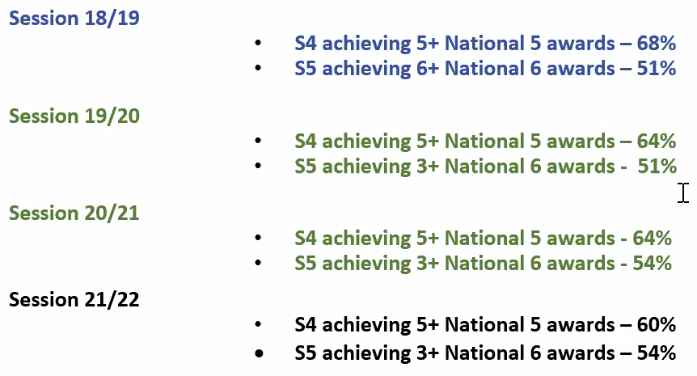

Insight data hasn’t been published yet so further details to a subject level will come at the next meeting once this has happened. Principle teachers are still working on their individual attainment details and drilling into the detail.

Support for attainment
Very pleased with this year’s Higher results in particular. Vincent Docherty as advised that trends in National 5 awards are reflective of the disruption from Covid and are seen across the region with this being the first year that pupils have experienced formal exam settings.

The school has developed a raising attainment plan.
This will include: Ongoing study support, lunchtime study sessions and masterclasses during study leave. Mrs Leslie in humanities has a good programme that will be used in Nov/Dev. There is an external company “Live and Learn” who are scheduled to come in just before the prelims to also assist in this area.
Mop up - pupils are identified towards the end of the year to ensure that they leave with as high a level in literacy and numeracy as is possible. There is a Goals programme delivered through the pupil development team for S4 pupils who require targeted intervention to help them achieve passes in their subjects with opportunities to have 1 to 1 mentoring to set them up before they leave school.

Excellence at Ellon
No real change but continuing to reinforce the values with emphasis on school routines
Recognition, there has been a lot of work on this recently. Mrs Buchan gives fast passes to pupils who have done well with merits in the previous week, which is very popular.

Survey on School Day
Parental survey has been issued to ask parental opinions on the school day, length of break/lunch etc. The school would ask for our support with this.

Lockdown Drill
Emergency response exercise to support planning for a community incident. An example of a previous scenario was a gas leak on Kellie Pearl way with an unknown intruder at the school. The drill is to be carried out to lockdown the school faculties are currently reviewing their processes. Further information is to follow for parents and an actual drill will happen in October. Evacuation drill is practiced every year, but this type of lockdown drill hasn’t been done in the school since Covid

Draft Mobile Device Policy
Needed a refresh, school is working on this, pupils will be consulted around this. If you are in a green zone you are allowed your phone eg break / canteen areas, classrooms are red zones but with phone use at the discretion of the teachers if required as learning tool in classes (e.g. to photograph homework tasks)
Activities Fair
Thurs 29/9/22 at lunchtime, all pupils are invited to attend. There is a list that’s been published but there are more being added to the list all the time.

Discussion regarding future Parent Council meetings – Virtual / In Person / Blended
Comments:
It would be nice to have at least 1 meeting each year in person.
Next one might be better online with it being in darker nights.
Could look at in-person in the new year.
Might be worth trying to get VC availability for any in-person meeting.
Blended meetings with zoom and with people being able to join online would be good.
In-person might help to get vacant posts filled.
Follow up with Pauline on seeing what options are available for VC.
Pauline is willing to do what is best for the parent council.
Do the school have a VC suite/tech that we could use? Pauline isn’t sure if there is anything, but she will check out with the technicians.

Vacant Positions – Vice Chair / Secretary / Parent Reps – S1 and S5
Any volunteers for any of the vacant posts?
Nick can cover the S5 in the interim until we can get someone with an S5 child. Fiona Callan current S4 rep offered to cover both S4 & S5 as she has a child in both years.
We can use the Facebook page to see if we can get any interest in the posts. S1 still vacant.

Facebook Group
If you aren’t already on the Facebook page (Ellon Academy Parent Council) please join. Please make sure you answer the questions that are asked on joining and if you are inviting parents and carers remind people to answer the questions.

Car Park
2 service buses are blocking the roads at the end of the school day (bluebird buses). Pauline to see if there is anything that can be done to help with this.
Some issues with parents dropping off doing 3-point turns at the drop off area and holding everyone else up rather than going up to the turning circle. Mrs Buchan to redistribute the parking leaflet.

Cost of Living Crisis response: Attached

Comfort Cabinet is restarting again.
School uniforms / toiletries / stationery etc., any other comfort closet items are being requested. How do parents donate? Just donate via the school office, either parents or pupils. The teacher who was running this is leaving so the school is trying to find a new member of staff willing to take the lead on it.
School has been looking at cost of living crisis response.
Mrs Buchan is going to ask Tesco if they are willing to help support a breakfast club for all.
Canteen and HE often have surplus that can be distributed to those in need.
Exec team are looking at asking for a foodbank item during fundraising days.
Mrs Buchan has links with the local churches in the town and is liaising with them in regard to the foodbank etc.
Investigating setting up charging points for pupils to charge their phones
There is funding available to pay EASA fees for young people who might need it.
Shower facilities could be offered.
Clothes washing/mending services/pre-loved services are all being considered.

Subject charges have been removed for Home Economics and Technical. (Local Authority initiative).
Transport - council have stopped paying for out of zone transport. The school is liaising with the council to review this.

Lockers
There has been a large turnover of staff in the school office recently, and most staff are new and being trained up. The main office tasks are SQA/timetabling/Registration and attendance etc. Lockers are not a priority for the new office staff now but once the new staff get up to speed this will recommence.

AOCB
Paying for dinners – Parents should use the complaints feature on the app to report issues.
Wifi in the school – there are areas of the school which have weak connection. PB to look at the possibility of boosters for these areas

Date of next meeting
Weds 30th Nov agreed

