Ellon Academy Weekly Information for parents/carers

To: All parents/carers
From: Pauline Buchan, Rector
Subject: Weekly Information Up-date
Date: Friday 18th December 2020
___________________________________________________________________________

I am very proud of the vast majority of pupils who have risen to the challenges that 2020 has thrown our way.
I am also humbled by our community resilience and collective spirit that has kept us going, even in the darkest days. As we enter the Christmas holidays and as 2020 draws to a close, it will be a time to pause, to reflect and to process everything that has happened, and more importantly, a time to rest and recuperate as we prepare for an uncertain but more hopeful 2021. I hope that no matter what you are doing for the Christmas holidays that you enjoy the break and I look forward to welcoming everyone back in the new year. I know that 2021 will continue to challenge us, but I also know that as a school community, we are strong enough to withstand any storm that comes our way.

Here are the updates for this week:

Virtual Assembly:
As is usual practice, this week’s Virtual Assemblies have been uploaded to our Facebook page for viewing.
There will be a Virtual Assembly on Tuesday 5th January 2021 to welcome pupils back to school and there will be no virtual assemblies during the January Assessment Block from Monday 11th January – Wednesday 27th January.

Next Parent Council Meeting
The last Parent Council meeting of 2020 was held virtually via Skype on Tuesday 15th December at 7pm.
We extended our grateful thanks to the Parent Council for their unfailing support over the past year.
The next virtual Parent Council Meeting is on Wednesday 3rd February at 7pm.

Covid-19 Up-date - Returning to School in January
In the event that we are still in Covid-19 Level 3 after the Christmas break, all S4/5/6 pupils returning to school from Tuesday 5th January will be required to wear face masks at all time, in and out of classrooms.
We will communicate if this is to be the case prior to the start of the new term to ensure that pupils and their families are aware.

Elevate Magazine:
As a result of Covid-19, it has been one whole year since the last edition of Elevate Magazine. The March 2020 edition had to be cancelled as we moved into lockdown and our priorities shifted significantly to learning from home. I hope you enjoyed reading about our pupil successes in the December 2020 edition.

Here is an article I forgot to add to Elevate. I’m on Santa’s naughty list for this Mr McLean!

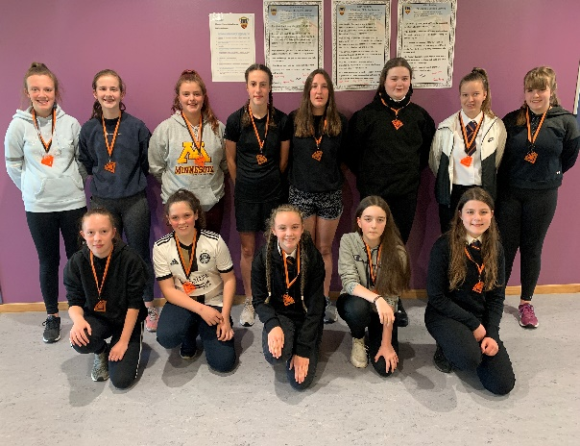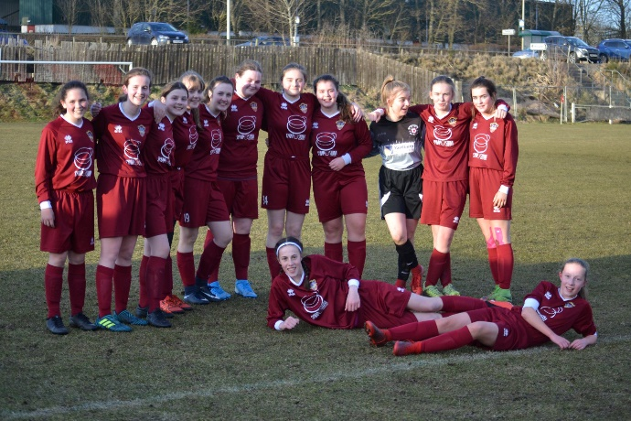

In May, Ellon Academy U15 girls football team were named as winners of the league for the 2019/20 season.
The girls were undefeated in the league and cup before Covid finished the season abruptly. In the last game, against Alford they won 2-1 with goals from Emily G and Ruby M which effectively clinched the league title.
The girls also reached a cup final and semi-final, but sadly never got the opportunity to play these games and add to their trophy win due to lockdown. Players of the season for 2020 were Milly U and Emily G. Well done!

Merry Christmas and have a lovely break,

P Buchan

Pauline Buchan, Rector
18.12.20

